Assignment 1: Architectural Drivers

|  |  |  |
| --- | --- | --- |
|  | Group 8 |  |
| Name | Email | Swedish Id |
| Khan, Muhammad Mohsin Qamar | muqm22@student.bth.se | 19980625T659 |
| Hassan, Syed Ali | syal22@student.bth.se | 19830417T674 |
| Shahzad,Ghilmaan | ghgh22@student.bth.se | 19950206T758 |

Ayyaz,Muawaz muay22@student.bth.se 19960513-T771

Contents

1. Introduction and Assumptions: 2

Description of system: 2

Functionality and Business Value: 2

System Assumptions: 3

2. Design purpose: 3

Why we were choosing architecture design: 4

3. Primary Functionality 5

Use Case Diagram: 5

Primary Functionality 6

Use Case 1: 6

Use case 2: 7

Use case 3: 8

3. Quality attributes: 8

QA 1: Performance: 9

QA 2: Maintainability 9

QA 3: Availability: 11

Utility Tree Matrix: 12

4. Architecture Concerns: 13

Context Diagram: 13

General Concerns: 13

Constraints: 14

# 1. Introduction and Assumptions:

## Description of system:

The largest glass manufacturing and manufacturing company want to expend their order software system. As Lycia is an industry leader in glass packaging and manufacturing in Sweden and Europe. As the company leading in glass manufacturing and packaging products such as glass bottles and other products to the food and beverage industry.

## Functionality and Business Value:

One of the biggest aspect to achieve the goal was they are committed to deliver high quality glass packaging products per client in a shorter span of time with delivery confirmation on sustainable environment practices to avoid degraded performance and unhappy customer.

Lycia IT teams offer solutions to EPR (Enterprise Resource Planning) that record vendor and customer order details, manufacturing and financial data). Many order tracking depend upon time provide by client, so one biggest priority for the company was to correct the problem and filled gap between customer and Lycia also another priority for the company was to collect customer information for future use to monitor the performance of the OTIS system.

The OTIS will perform three basic operations

* Order Operation:
* Track Operation
* Report Operation

The development plans for the company want to develop OTIS Customer Module for its 1.0 million customers. Lycia intends to launch a Digital CRM Application for customer to achieve below goals

The CRM module will be hosted on a Cloud environment. Lycia will have integration with customer and DHL express for logistic and order dispatching information.

### System Assumptions:

•Delivery: Production material is available when needed during production (LPROD) system when the order planned (ready for production) in any case the material is not available then OTIS system will highlight the alert.

•Budget: Estimate the cost of OTIS project. The system cost will stay the same as initially budgeted cost.

•Training: OTIS system training will be conducted internally by IT team so no additional cost will be charged

•Finance: Lycia provides the project budget allocation separately. This mean any resources and system maintenance should have specific budget.

•Scope: delivery time for project completion of OTIS project is six month.

•Recourses: Recourses allocation defined under separate team supervision and budget allocated by Lycia finance department separately.

# 2. Design purpose:

The good software architecture gives importance for Lycia OTIS. It should be clearly elaborate why we are using great software architecture design.

Implementing a vision:

* Lycia architecture is the state of art IT infrastructure and it’s develop a vision of the OTIS needs to with IT structure.

List of Business Goals and justification:

1. Give customers an online platform where they can access their order status online all acrossthe world
2. Increase the production of the company by reducing the workload on Key Account Managers and Production workers
3. Saving audit logs and maintaining the records of the order
4. Provide value to customer by providing the state-of-the-art order tracking system

### Why we were choosing architecture design:

The good software architecture gives importance for Lycia OTIS. It should be clearly elaborate why we are using great software architecture design.

Below are the some important aspect used in Lycia OTIS:

* + Build solid foundation for the software project
  + Make scalable platform
  + Increase performance
  + Cost effective solution
  + To avoid code duplicity
  + System should be secure and build with highest security authentication.
  + For better maintainability of code by using latest approach it’s easier to find defects and bugs.

# 3. Primary Functionality

## Use Case Diagram:

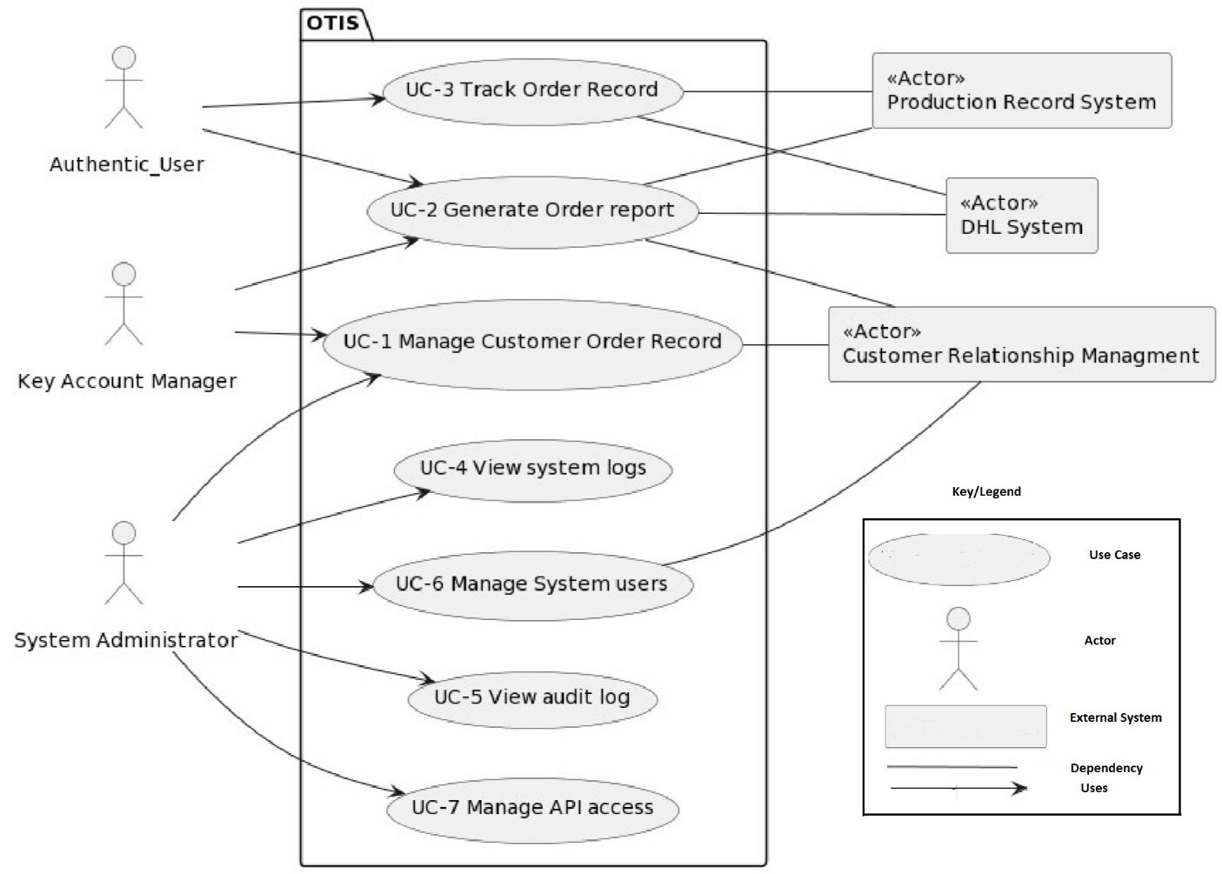

|  |  |
| --- | --- |
| Use Case | Description |
| UC-1 Manage Customer  Order Record | User details of the Lycia customers is imported from the customer management system. System maintains the data if user has a one or more orders and their order status in the system. User can add, view delete and update customers details, customer order details and order status. |
| UC-2 Generate Order Report | User can generate report of the status of the order. Order can be completed or could be in production, packing, warehouse, delivery and completed. The report mentioned the date and time of the order started and also total raw materials needed for the manufacturing of the order. The format of the report will be CSV and PDF. |
| UC-3 Track Order Record | User can view their order. It will provide more detail about the order and currently where the order stage is. User can check by clicking on the order detail. Total details of the order would be displayed. In Production, system displays raw material details, how much the order is completed and estimation of the order to be manufactured. In packing, the system displays how much packing of the order is completed. Delivery displays the location where the |

order is currently placed. System notifies the customer when the status of the order changes.

|  |  |
| --- | --- |
| UC-4 View System Logs | OTIS system records all the activities happening the system. If system calls an API to get data from external system, Report generation by user, order status changed notification is saved in the system. System Errors are also saved in error logs. |
| UC-5 View Audit Logs | Every operation with respective to its time frame and things are automatically saved In the server. Also every error with error description and error time is also saved in the system |
| UC-6 Manage System Users | System administrator can add, update, view and delete the system users and their rights to access. System can modify the users of the system, their access rights. |
| UC-7 Manage API Access | Through the authorization of their login in the system, system check and verifies that the user have the rights to access to call API from external system(Production Management system, DHL  system, Customer relationship management system) |

## Primary Functionality

### Use Case 1:

|  |  |
| --- | --- |
| Use Case Name | Manage Customer Order Record |
| Use Case ID: | UC1 |
| Actor (): | Key Account Manager, Customer Relation System |
| Type | Primary |
| Basic Flow: | Lycia’sKey Account Manager click on the view Data Record button on the system. System provides the complete information about the order placed by the clients. Key Account Manager view the detailed information form material procurement to the final order dispatch. System provides the details of customer order details and progress of order  Customer Relation System have access to the customer records and keep update to show the status of the order with customer details. |
| Reasoning: | The reason for choosing this as UC1 is that Lycia’s clients and KAM (Key Account Manager) wants to view data record as their perspective roles and system authentication i.e., client use this to viewtheir order and shipping details and KAM will use this to view the detailed information and also add or update the new clients in system. |
| Use-case related to business Goal | Customer Order Data order should be automated as this system manually take time and create customer dis-satisfaction. |

### Use case 2:

|  |  |
| --- | --- |
| Use Case Name | Generate Order Report |
| Use Case ID: | UC2 |
| Actor (): | System Administrator, Customer Relation System |
| Type | Primary |
| Basic Flow: | System administrators give access to Lycia customers. Customer logs into the system by provided credentials by Lycia IT support. User logs into the web Portal.System redirected the user in user dashboard. System displays all the customer order list. Customer selects the orders and generate the reports. System asks the user to Select the report format (PDF, WebPage). User selects the report format and clicks on generate report button. System downloads the order report in selected format in the user system |
| Reasoning: | The reason behind choosing this as UC2is that it managesand access the privileges to users into system is the main role of system administrator and customer relation system so, UC2 defined and elaborate about manages system users, and user records. |
| Use-case related to business Goal | OTIS system would provide order reports as order report of the system approximately 2 months to compile. Order report needed to be automated in order to give customer details about their order progress. |

### Use case 3:

|  |  |
| --- | --- |
| Use Case Name | Track Order Record |
| Use Case ID: | UC3 |
| Actor (): | Authentic, User, DHL Shipping |
| Type | Primary |
| Basic Flow: | An authentic Lycia’s client logs into the system. System redirect the user to user dashboard. User click on order tracking button. System redirects the user to order tracking page with list of all orders. User select the order and provide the unique tracking Id given by the system. System displays the order warehouse details and order position details. |
| Reasoning: | Track record is the first main requirement for the OTIS which Lycia plans to develop so that the Lycia’s clients track their record, check their order status and shipping status so, this one is chosen as  UC3. |
| Use-case related to business Goal | Customer wants to track order information record as legacy process took 2 month to process. Our business goal is to automate the order tracking. We developed the functionality to get real-time order tracking data to customers for client satisfaction |

# 3. Quality attributes:

Three quality attributes of the system is detailed below:

* + Performance
  + Maintainability
  + Availability

## QA 1: Performance:

Justification:

Currently our Manual system provide reports to the customer within 2 months. As our business goal is to reduce the time taken to generate reports to the customers, performance become one of the main quality attribute. Our system should give perform in less time and give customer update about their order status close to near time.

General Scenario:

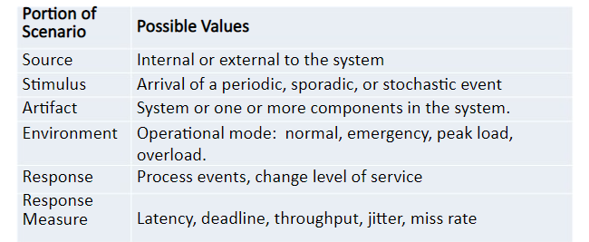

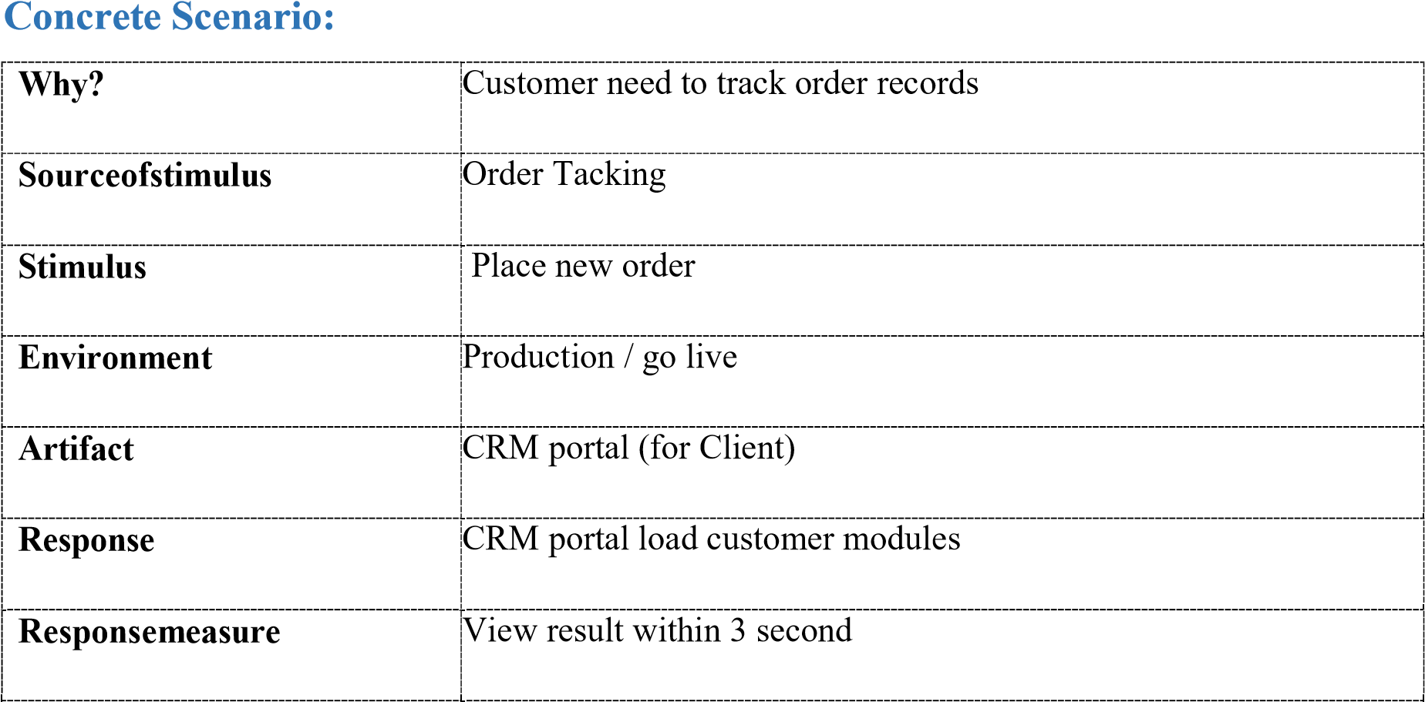

## QA 2: Maintainability

Justification:

As our system have different modules, our system should have the ability to add new modules and new functionality within the module. After this build, system could ask to change some functionality in a module or add new module. Every system does through a series of change according to the user needs, so the system has to change. Maintainability is important to add these changes without changing the whole system with less effort General scenario:

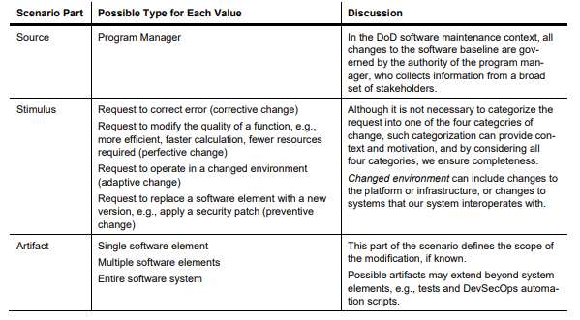

Concrete Scenario:

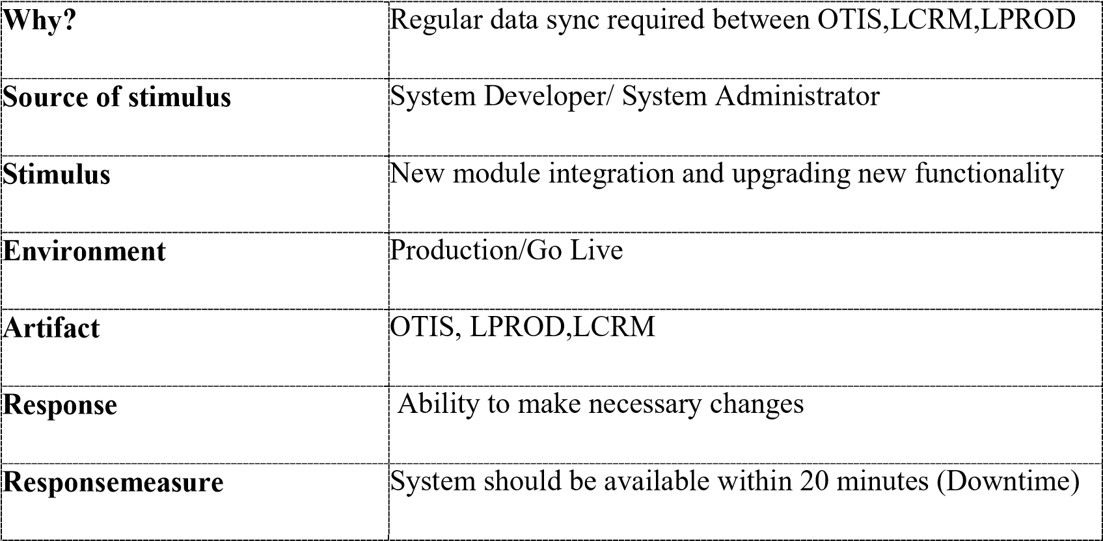

## QA 3: Availability:

Justification:

One of the main business goal of the user has a transparency in their order so they can view their order stages as soon as possible. Our system would be up and running in working hours 8:00 – 18:00 to provide user to check their order status.

General Scenario:

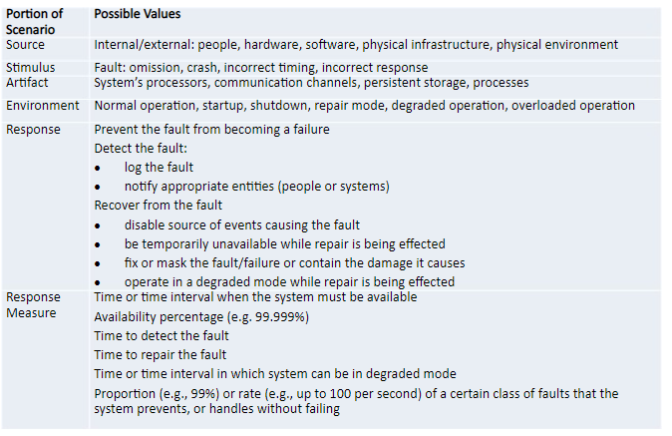

Concrete Scenario:

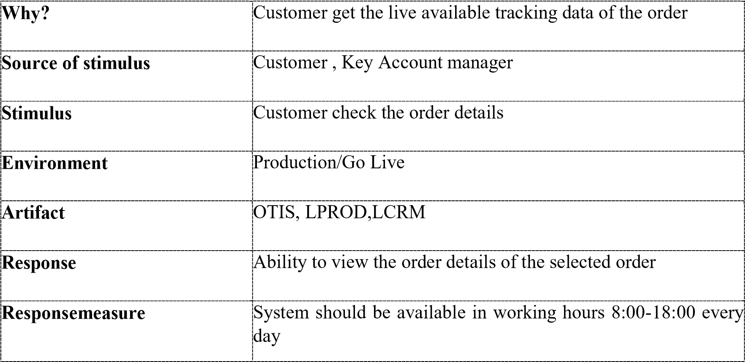

## Utility Tree Matrix:

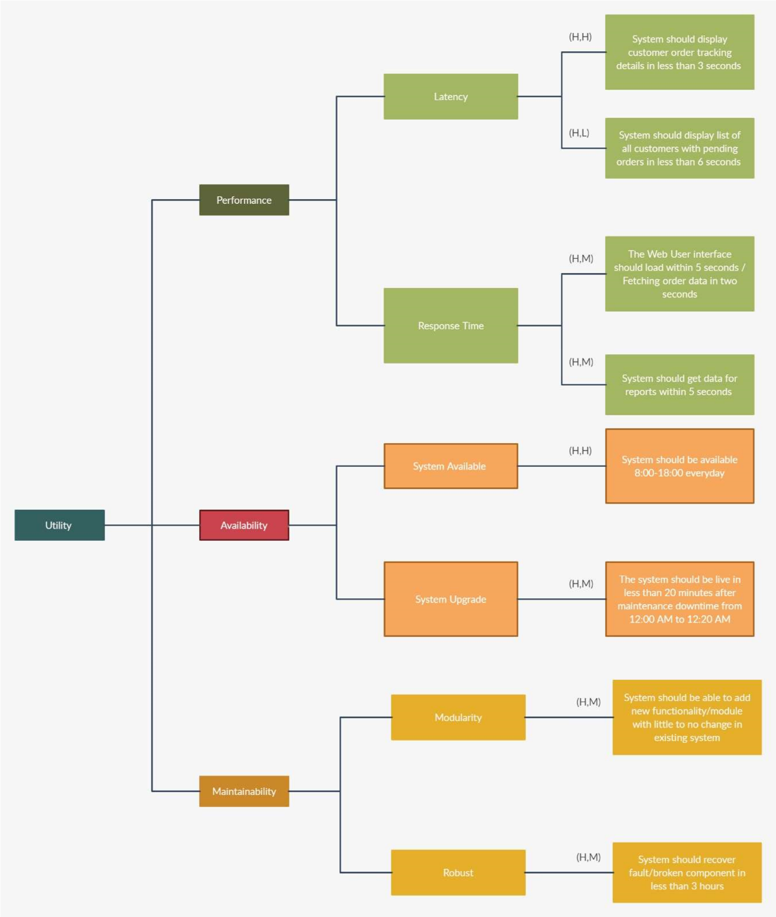

# Architecture Concerns:

# Context Diagram:

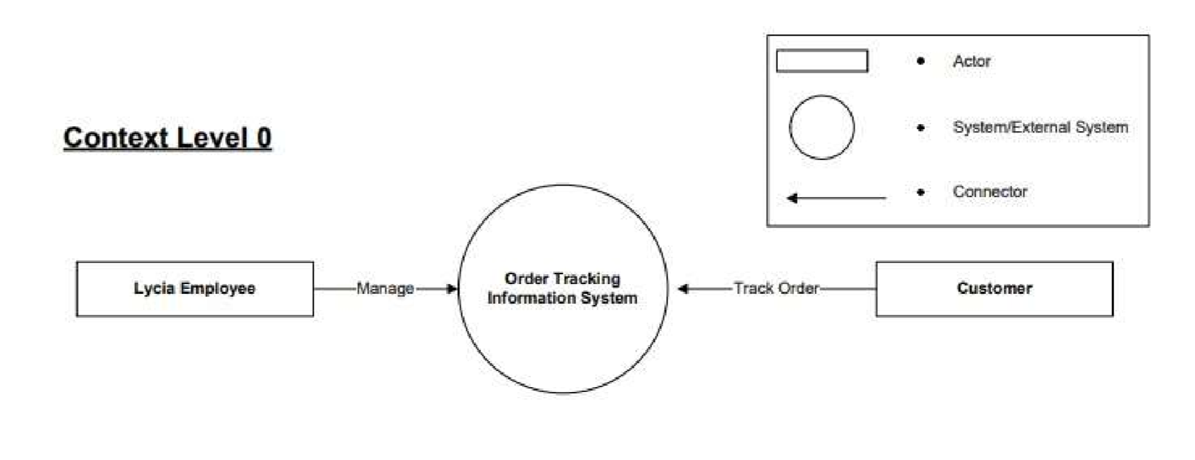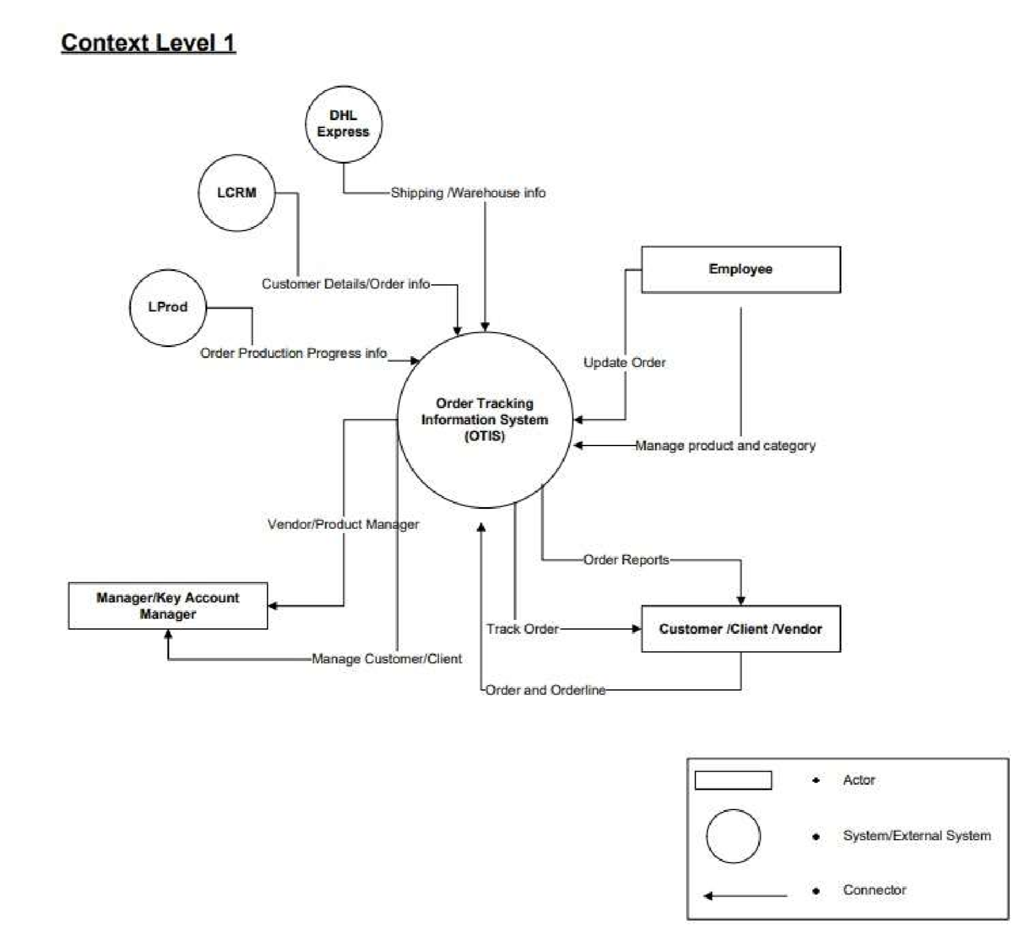

## General Concerns:

* 1. OTIS system has data dependency on DHL Express system. Our system could fail if there is any change in system.
  2. IT support team would be available for Lycia clients from 8:00-18:00 from Monday to Friday. IT support would help the clients to operate the system and response to queries of customers.
  3. System Configuration and enhancement will be considered completed if any one of the following is completed. Any changes or enhancements afterwards will be billable:

O UAT Signoff

O Advice to Go Live Sign Off

* 1. More requests in the system would result in low performance in the system. Additional of server with load balancer could be needed in future.
  2. Our system would down at midnight time 12:00 AM-12:20 AM. IT team working at this team is needed.
  3. Teams would be divided into people of 5-10 people and they develop and maintain in respective domain according to their expertise. The domain is developed in Database, Backend, DevOps, Frontend and Testing teams
  4. We have a layered architecture. Frontend Team would depend upon the backend team. If change is needed, frontend wait for the backend team to implement the change.
  5. Our system will save the user details: their email, password and level of access in the system in separate module/component
  6. Our system will keep logs of the event and save them in server in logging directory. System Admin would have the access to view the logs through interactive UI.
  7. Small modular structure will give us easy to check which component/module isn’t working by using exception handling in the system.
  8. Pre-build user logins in the system will be created for System Admins and Key account managers and authorization and access right will be handled.

## Constraints:

Technical Constraints / Runtime Interface Requirements

Hardware and Software Infrastructure

Following applied technologies - operating systems - middleware - databases - programming languages:

|  |  |  |
| --- | --- | --- |
| **SR No** | **Constrains** | **Justification** |
| C1 | Windows/Linux | As our system would be web based, web browser would need an User interactive Operating system for displaying the data |
| C2 | Programming Language: Java Spring Boot | Our existing system is made in Java Spring Boot and our In-house IT team has an expertise in Web development. So developing OTIS would be result in quality product. |
| C3 | SQL Server | SQL server would be used in getting and retrieving the data of order and users |
| C4 | DHL express API to get the customer order tracking and warehousing details | Order tracking data would come from external system as we do not manage the data. We have to rely on their given API endpoints |
| C5 | LPROD module API to get the production details of customer order | The production data of orders would come from external system and will have to rely on their data for our system to work |
| C6 | 6 months for develop and integrate the system | As the time given by the Lysia owner to develop the system within 6 months, we need to develop and integrate the system |